Lab 1: Barrel Shifters

Multi-function barrel shifter

* 8-bit shifting with right- and left-rotating circuits and 2-to-1 mux
* Video demonstration: <https://streamable.com/wac634>

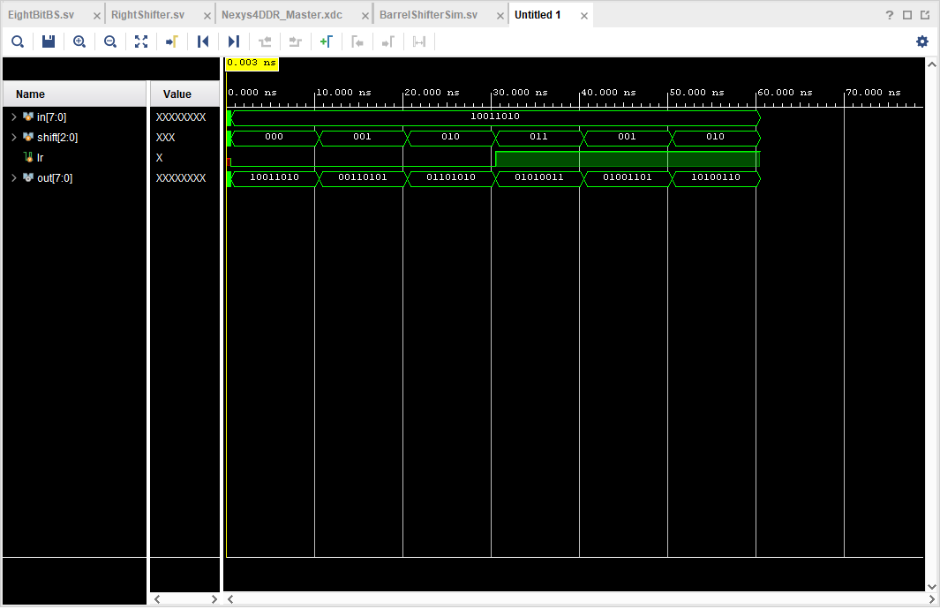

Left- and right-shift simulation result for 8-bit circuit

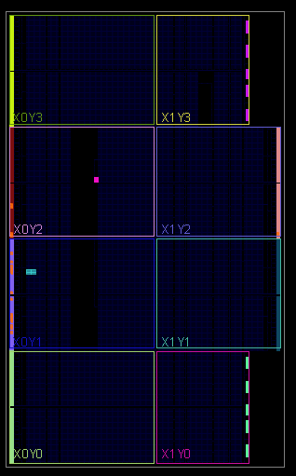

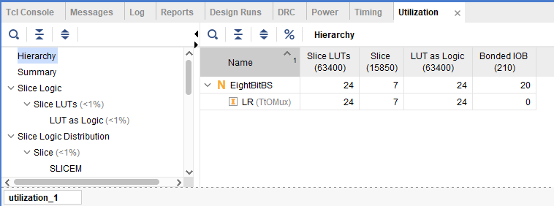

Resource utilization report upon implementation shows 24 LUTs are utilized

* 8-bit shifting with right-rotate shifter and pre/post reversing circuits

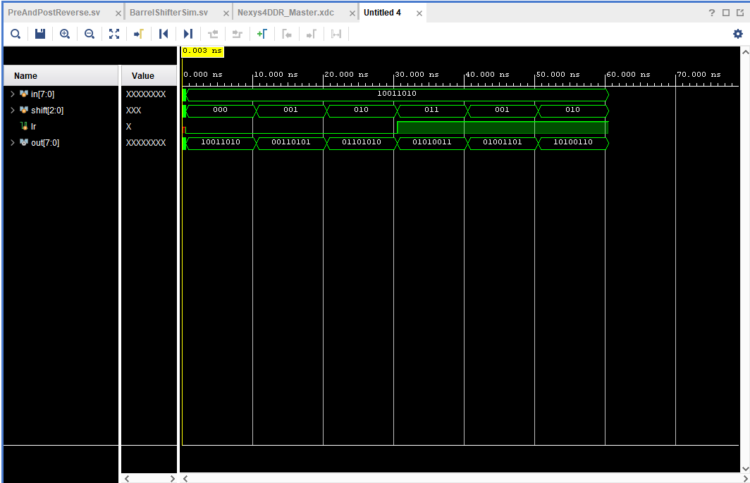

Left- and right-shift simulation result for 8-bit shift/reverse circuit

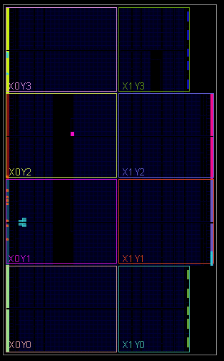

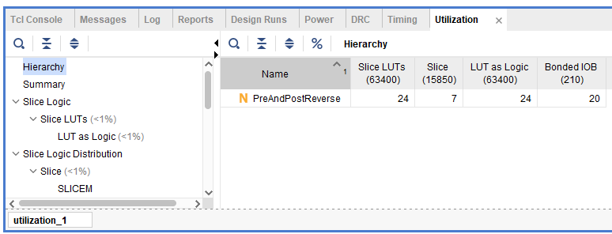

Resource utilization report upon implementation shows 24 LUTs are utilized, similar to the previous circuit implementation

* 16-bit shifting (combined)
  + Right- and left-rotating circuits and 2-to-1 mux
  + Right-rotate shifter and pre/post reversing circuits

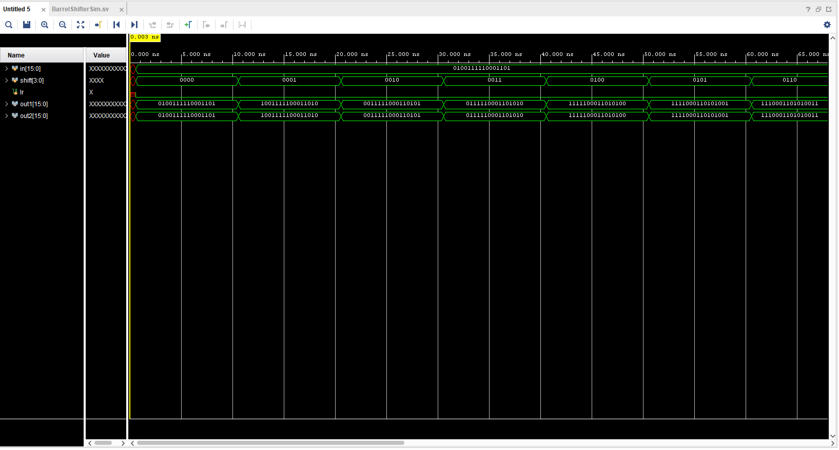

Left-shift simulation result for both 16-bit circuit implementations

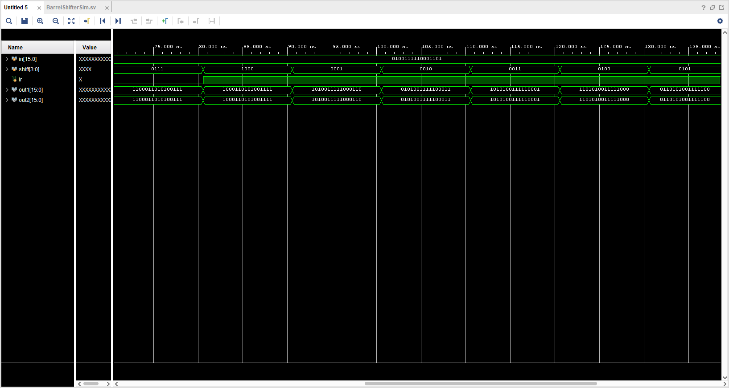

* Right-shift simulation result for both 16-bit circuit implementations
* 32-bit shifting (combined)
  + Right- and left-rotating circuits and 2-to-1 mux
  + Right-rotate shifter and pre/post reversing circuits

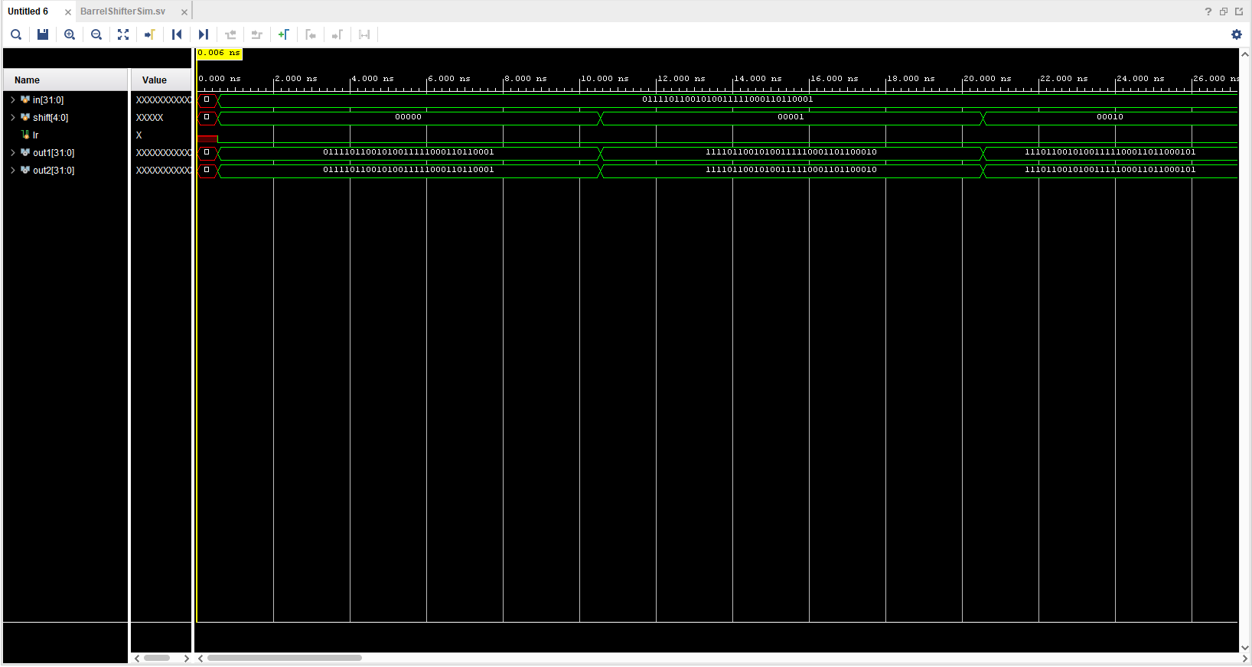

Left-shift simulation result for both 32-bit circuit implementations

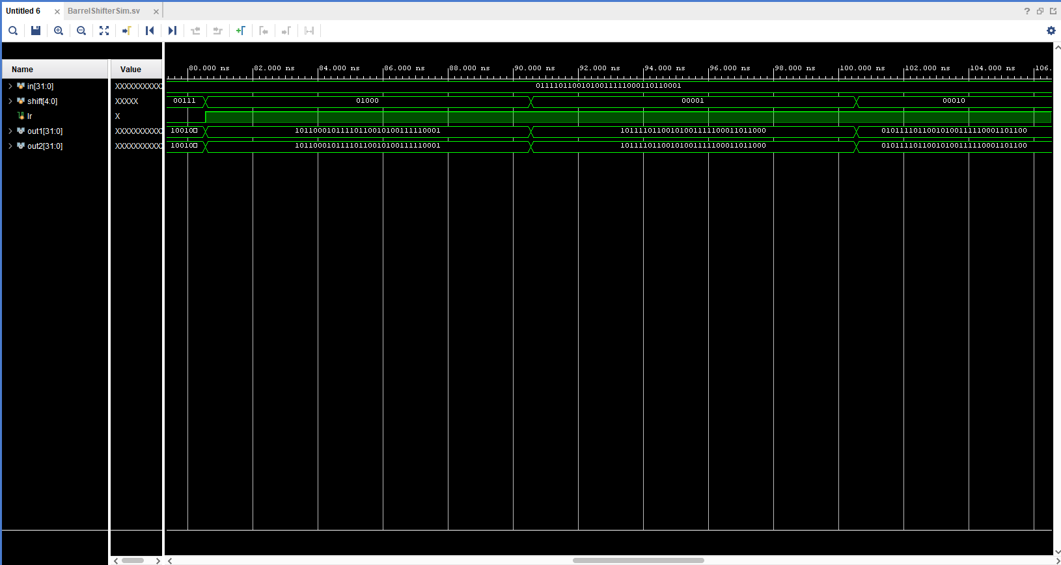

Right-shift simulation result for both 32-bit circuit implementations

* Nth-bit shifting

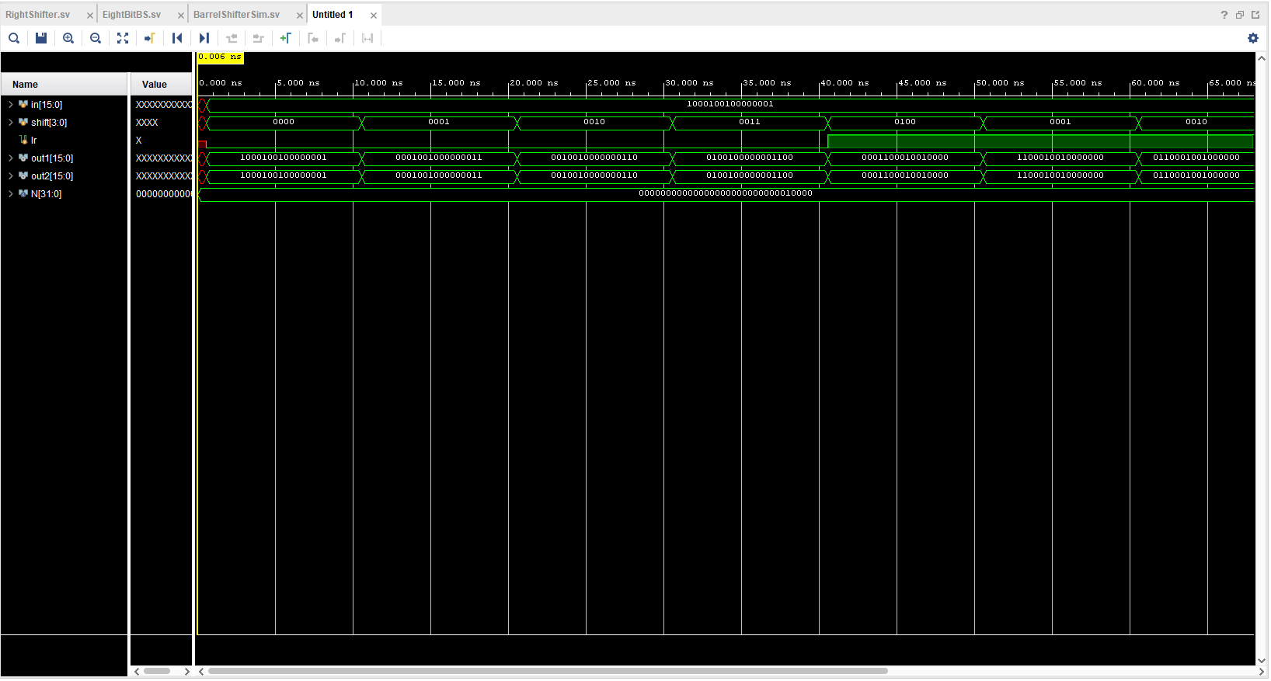

Nth-bit shifting simulation result with parameter N set to 16